**CASE STUDY OF MICROWAVE OVEN**

# INTRODUCTION:

A typical example of such an embedded system is in your microwave oven. The microwave often has a display, keyboard, and a number of sensors and actuators. Sensors can be a temperature sensor or the sensor that detects whether the door is closed. Actuators can be the electronic switch that controls a microwave tube or a system that controls the rotational speed of a fan.

# BLOCK DIAGRAM:

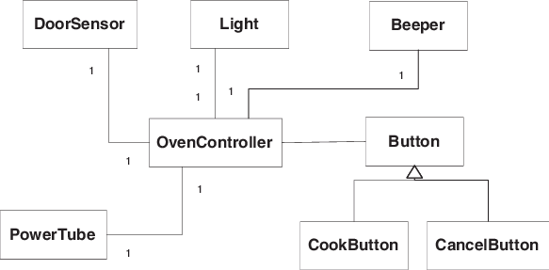

• The microwave oven has two buttons: a cook button and a cancel button. When the cook button is pressed once, the oven will cook for 1 minute. Cooking can be terminated at any time by pressing the cancel button.

• Whenever the oven is cooking, the light inside the oven must be on to allow the cook to see the food. The light should also go on when the oven door is opened. At all other times, the light must be off.

• Pressing the cook button while the oven is cooking extends the cooking time by 1 minute. One can then press the cook button any number of times during cooking to add as many minutes as desired.

• When the oven completes cooking, the power tube and the light are turned off. The oven will then alert the cook by beeping three times.

• While the oven is cooking, opening the door will interrupt cooking. Any remaining cooking time is cleared and the oven will not beep.

# REQUIREMENTS:

# HIGH LEVEL REQUIREMENTS:

1. The user opens the door.
2. The light is turned on.
3. The user closes the door.
4. The light is turned off.
5. The user presses the cook button.
6. Single beeps.
7. The light is turned on.
8. The power tube is energized.
9. The system signals the timer to add 60 seconds.
10. The system signals the timer to start.
11. After elapsing the cook time, the timer notifies the system.
12. The power tube is turned off.
13. The light is turned off.
14. Beep three times.

# LOW LEVEL REQUIREMENTS:

1a. The user presses the cook button without putting food.

1b. The user presses the cook button when the door is open.

11a. Before elapsing the cooking time, The user presses the cook button to increase cooking time.

11a-1. The system signals the timer to add 60 seconds.

11a-2. Continue to step 11

11b. Before elapsing the cooking time, The user presses the cancel button to cancel cooking.

11b-1. Single beeps.

11b-2. The power tube is turned off.

11b-3. The light is turned off.

11b-4. The system signals the timer to stop.

11b-5. The scenario ends.

11c. Before elapsing the cooking time, The user opens the door and the cooking is canceled.

11c-1. The power tube is turned off.

11c-2. The light is turned off.

11c-3. The system signals the timer to stop.

11c-4. The scenario ends.